Denis Deronjic 1231829

**HOMEWORK 3**

**Introduction**

In this homework the aim is to train and test neural network models to solve Reinforcement Learning problems.

The first task requires to implement some extensions to the code that we have seen during the lab lecture. We have to tune the model in order to achieve the same accuracy with fewer training episodes.

The second task requires to implement a neural network model to solve the same problem as in the first task but using directly the screen pixels rather than the compact state representation used in the first task.

The third task requires to train an RL agent on a different Gym environment. The environment chosen is MountainCar.

**CARTPOLE-V1 ENVIRONMENT**

The cartpole-v1 environment consists of a pole attached by an un-actuated joint to a cart which moves along frictionless track. The system is controlled by applying a force of +1 or -1 to the cart. The pendulum starts upright, and the goal is to prevent it from falling over. A reward of +1 is provided from every timestep that the pole remains upright. The episode ends when the pole is more than 15 degrees from vertical, or the cart moves more than 2.4 units from the center.

This problem is modeled using a **state space vector** of dimension 4 which represents the current state of the cart and the **action space vector** of dimension 2 which represents the actions that the cart should take given its current state described in **state space vector**.

The **state space vector** is composed as follows:

* **0: Cart position** with the domain in [*-4.8, 4.8*]
* **1: Cart velocity** with the domain in [*-inf, +inf*]
* **2: Pole angle** with the domain in [*-24°, +24°*] or in radians [-0.418, +0.418]
* **3: Pole angular velocity** with the domain in [*-inf, +inf*]

The **actions space vector** is composed as follows:

* **0:** Push cart to the left
* **1:** Push cart to the right

The maximum score that the cart can achieve is 500. We aim that our model can learn in order to make the cart achieve the maximum score of 500.

The reward of +1 is given for every step that the pole remains upright. Using only this type of reward will cause our agent to move outside of the screen. This is not a behavior we want. We want to see the cart in the screen. To achieve this behavior, we need to add a penalty on the position in order to let the cart stay near the center of the screen.

The **reward** is the following:

***reward = env_reward -1 \** |*cart_position*|**

where ***env_reward*** is the +1 reward achieved from the environment and **|*cart_position*|**is the absolute value of the current position of cart in the environment. When the position of the cart is higher in absolute terms, higher is the penalty given.

The environment will run until one of these conditions are reached:

* Pole angle is more than ±12°
* Cart Position is more than ±2.4 (center of the cart reaches the edge of the display)
* Episode length is greater than 200

**MODEL HYPERPARAMETER TUNING**

The network architecture used to train in this environment is the following:

* Input of 4 (the state space vector)
* First linear layer with number of neurons of 128
* Second linear layer with number of neurons of 128
* Output layer of dimension 2 (the action space vector)

The activation function used is tanh.

The policy used is the softmax policy. The temperature used for the softmax policy is the following:

$$softmax_temperature{=init_val* e^{(-\frac{log\left(initial_val\right)*mul_iter}{num_iterations})}}^{i}$$

Where ***initial_val = 9, num_iterations = 1000*** and ***mul_iter = 10*** are the hyperparameters tuned for this function.

In the following you can see the plot of this function

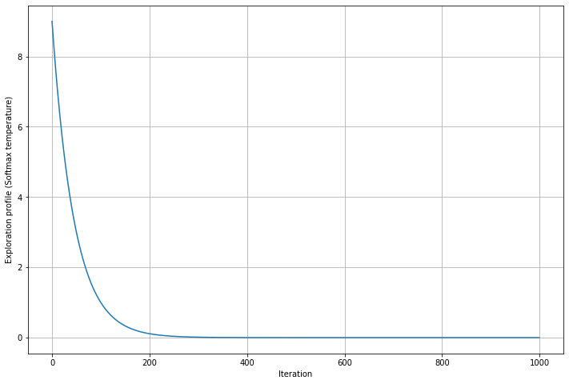

The hyperparameters used are:

* **Gamma:** 0.98
* **Replay memory capacity:** 10000
* **Learning rate:** 0.02
* **Target net update steps:** 10
* **Batch size:** 128
* **Bad state penalty:** 0
* **Min samples for training:** 1000

The parameters are the same as in lab rather than gamma that is 0.98.

With these parameters, the convergence is faster. The convergence is reached after 600 episodes as you can see in the following figure.

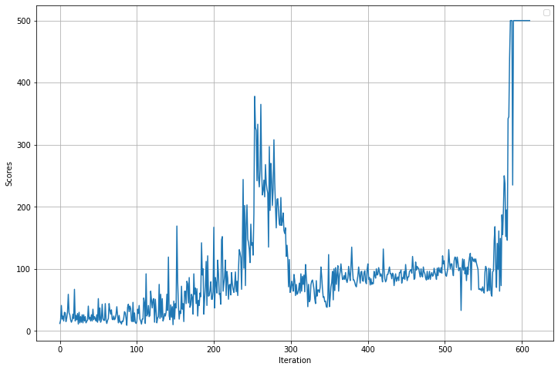

**MOUNTAINCAR-V0**

This environment consists of a car that is on a one-dimensional track, positioned between two “mountains”. The goal is to drive up the mountain on the right. However, the car’s engine is not strong enough to scale the mountain in a single pass. Therefore, the only way to succeed is to drive back and forth to build up momentum.

In the following you can see the environment

This problem is modeled using a **state space vector** of dimension 2 which represents the current state of the car and the **action space vector** of dimension 3 which represents the actions that the car should take given its current state described in **state space vector**.

The **state space vector** is composed as follows:

* **0: Car position** along the x axis with domain in [*-1.2, 0.6*]
* **1: Car velocity** with domain in [*-0.07, 0.07*]

The **actions space vector** is composed as follows:

* **0:** Push left
* **1:** No push
* **2:** Push right

The **score** of this environment is the car’s position since the **goal** of this environment is achieved when the car goes to the 0.5 position.

The **initial** position of the car is the position -0.5, at the bottom of the hill.

The **reward** function is calculated as follows:

***Reward = position + 0.5***

Where the constant 0.5 is added in order to have a 0 reward in the initial position.

The car is rewarded also if it reaches a good position in the hill, for instance, when the car reaches a position greater or equal than 0.2, a +1 reward is added to the current reward.

A penalty of -2 is added when the car doesn’t achieve the maximum position that it reached previously. This penalty is useful to stimulate the car to improve itself by trying to reach a better position.

The **episode ends** when the position 0.5 is reached, or if 200 iterations are reached.

The policy used is the epsilon greedy policy with the epsilon value following the following function divided by the initial value of this function in order to have the **epsilon** value between 0 and 1. This function is similar to the temperature function of the first task but with different parameters.

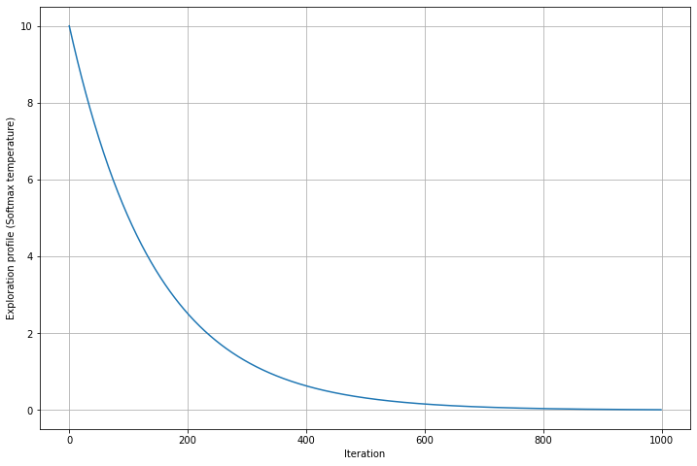

In this case the parameters used are ***initial_val = 10, num_iterations = 1000*** and ***mul_iter = 3.***

This function ensures higher probabilities to choose random actions in the first 200-300 episodes and the best actions based on car’s state in the later training.

The hyperparameters used to train this environment are:

* **Gamma:** 0.97
* **Replay memory capacity:** 10000
* **Learning rate:** 0.02
* **Target net update steps:** 10
* **Batch size:** 128
* **Bad state penalty:** 0
* **Min samples for training:** 1000

As you can see in the following plot, the convergence is reached after the 900th episode. The model started to achieve the **goal** after the 500th episode but it didn’t yet learn how to achieve the goal much more frequently. Best parameter optimization can improve the convergence speed of the network.

